**Practical No.1**

**Date: 17/07/2019**

**1.a)**Draw an ER diagram for Hospital Management system

Medical Record

has

has

Doctor

Hospital

Patient

Admitted in

N 1

1 1

N N

**1. b)** Draw an ER diagram for Online Hotel Management system.

Guests

1 N

Book

Request

N 1 1 N

Reserve

Reservation

Rooms

**1. c)** National Hockey League:

* The NHL has many teams,
* Each team has a name, a city, a coach, a captain, and a set of players,
* Each player has a name, a position(such as left wing or goalie), a skill level, and a set of injury records,
* A team captain is also a player,
* A game is played between two teams(referred to as host_team and guest_team) and has a date(such as May 11th, 1999) and a score(such as 4 to 2).

Construct a clean and concise ER diagram for the NHL Database using the chen notation as in your textbook. List your assumptions and clearly indicate the cardinality mappings as well as any role indicators in your ER diagram.

Game

Belongs to

Captain

Team

Player

Log

Injury record

Host Guest

1 1

N 1 1 N

**Practical No. 2:**

**Date: 29/07/2019**

**2.a)** Create a Relational Database of a Hospital Management system.

Create Database:

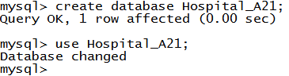

Create Table:

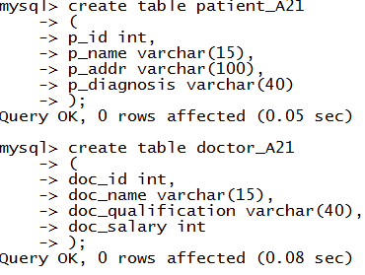

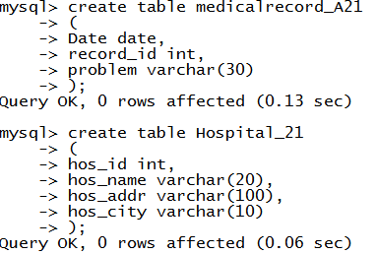

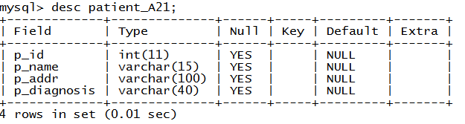

**2.b)** Create a Relational Database of an Online Hotel Management System.

Create Database:

mysql>create database Hotel_A21



Create Table:

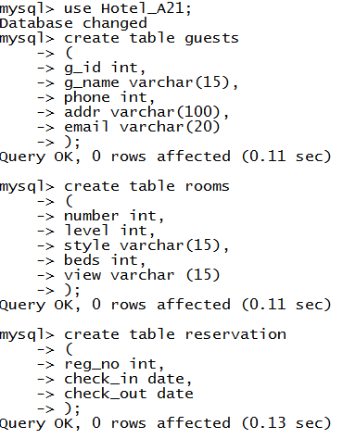

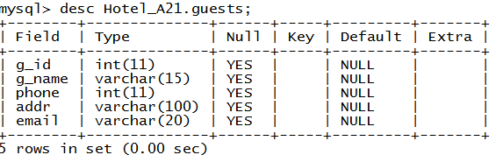

**2.c)** Create a Relational Database for the National Hockey League.

Create Database:



Create Table:

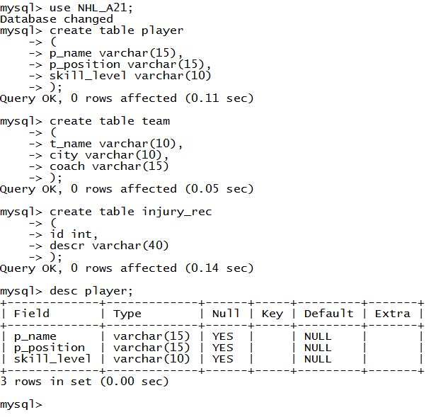

**Practical No.3**

**Date: 19-08-19**

**Perform the following:**

1. create database
2. create table employee (emp_id, emp_name, salary, dept) without constraint.
3. create the above same table with primary key constraints.
4. using alter and add new column "age".
5. modify column emp_name as varchar(100)
6. drop column "age"
7. add multiple column age, designation.
8. rename table employee as "EMP".
9. insert 2 records in table EMP
10. truncate table EMP.
11. drop table EMP.

**1.**create database





**2.**create table employee (emp_id, emp_name, salary, dept) without constraint.

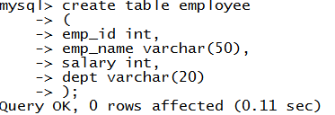

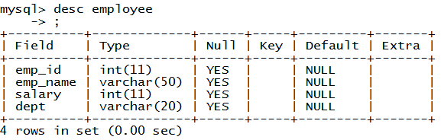

**3.**create the above same table with primary key constraints.

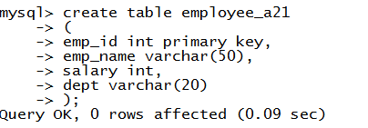

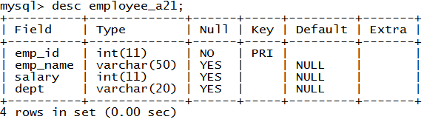

**4.**using alter and add new column "age".

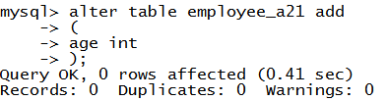

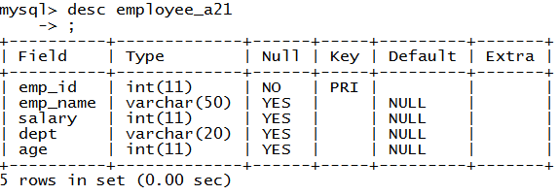

**5.**modify column emp_name as varchar(100)



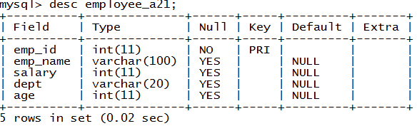

**6.**drop column "age"



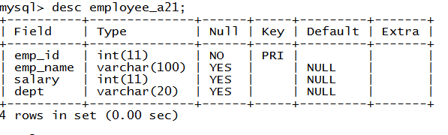

**7.**add multiple column age, designation.

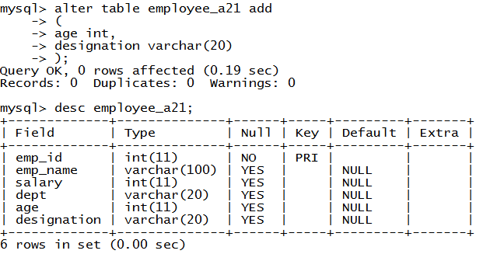

**8.**rename table employee as "EMP".



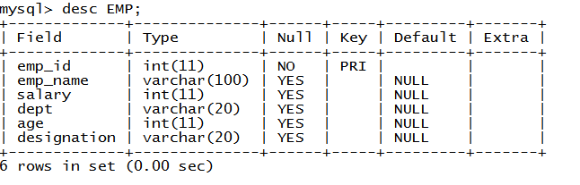

**9.**insert 2 records in table EMP





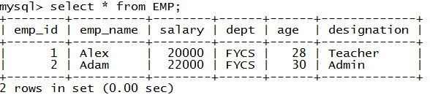

**10.**truncate table EMP.





**11.**drop table EMP.





**Practical No.4**

**Date: 29-08-19**

**Title: Constraints.**

1. Create table emp with attribute emp_id, name, salary. Also give primary key constraints to emp_id column and unique contraints to name column.

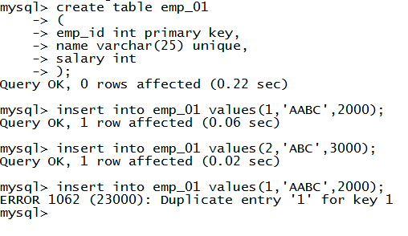

2. Create table emp_dept, with attributes emp_id, designation, dept. Give foreign key constraints to emp_id column, not null constraints to designation column.

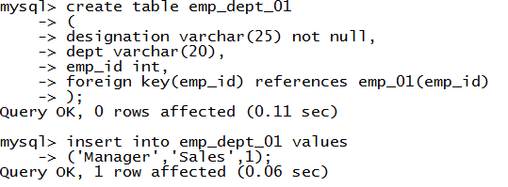



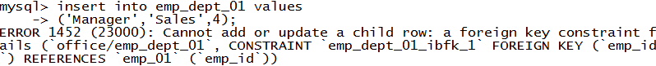

3. Create table student with default and check constraints. add constraint after table creation to one of the column

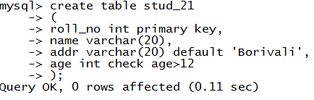

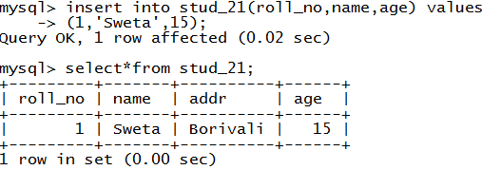

**Practical No.6**

**Title: Select Statements.**

where clause

like

between

having

group by

ordered by

add, or, in operators

**Practical No.7**

**Title: Aggregate functions and Scalar Functions**

**Practical No.8**

**Title: Creating views**